
KIT – KALAIGNAR KARUNANIDHI INSTITUTE OF TECHNOLOGY (AN AUTONOMOUS INSTITUTION)
Coimbatore – 641402 Affiliated to Anna University, Chennai
Accredited by NAAC with ‘A’ Grade | Accredited by NBA

Array Implementation Of Stack

COURSE CODE : B23CST302
PROJECT REPORT

PROJECT TITLE:
Array Implementation Of Stack

GUIDED BY:
M S. Ranjith

TEAM MEMBERS | REGISTER NO
HARIPRASATH T | 711524BCS309
DHARASHAN N | 711524BCS038
SHRUTHI M | 711524BCS317

ABSTRACT

A stack is a fundamental data structure in computer science that operates on a Last In, First Out (LIFO) principle. It allows operations like pushing data onto the stack, popping data from the stack, and inspecting the top element. A stack can be implemented using various underlying data structures, such as linked lists, dynamic arrays, or static arrays. This abstract focuses on the array-based stack implementation, which is a popular approach due to its simplicity and efficiency in terms of both time and space.

In an array-based stack, an array serves as the underlying storage to hold the stack elements. The stack operations—push, pop, and peek—are implemented using the array's properties. A critical factor in array-based stack implementation is the top pointer, which keeps track of the position of the most recently added element in the stack. The stack is initialized with a predefined maximum size, and any attempt to push beyond this size results in a stack overflow error.

The primary operations of an array-based stack are as follows:
- Push- This operation adds an element to the top of the stack.
- Pop- This operation removes the top element from the stack
- Peek- This operation allows the user to view the element at the top of the stack without removing it.
- Is empty- This function checks whether the stack is empty

INTRODUCTION
A stack is a fundamental linear data structure that follows the LIFO (Last In, First Out) principle, where the element inserted last is the first to be removed. Stacks are widely used in various applications such as expression evaluation, function call management, backtracking algorithms, and memory management. One of the simplest ways to implement a stack is by using an array, where elements are stored in contiguous memory locations.
In an array-based stack, a variable called top is used to track the index of the currently inserted element. Basic stack operations such as push, pop, and display are performed using this index while ensuring that overflow and underflow conditions are handled properly. This method is efficient, easy to understand, and performs operations in constant time O(1). Due to its simplicity and speed, array implementation is commonly used in embedded systems, compilers, and many software applications.

OBJECTIVES
- To understand the concept of the Stack data structure and its behavior using the LIFO (Last In, First Out) principle.
- To develop a stack using arrays and implement essential operations such as Push, Pop, and Display.
- To learn how to handle stack overflow and underflow conditions, ensuring proper error management during operations.
- To practice modular programming in C, by organizing stack operations into separate functions for readability and reusability.
- To implement menu-driven programming, allowing interactive execution of stack operations through user input.
- To analyze the time and space complexity of stack operations and understand why array implementation provides constant-time performance.
- To enhance problem-solving skills and strengthen understanding of linear data structures through practical implementation.

Problem Statement

In computer science, the stack is a fundamental data structure that operates on a Last In, First Out (LIFO) principle, where the most recently added element is always the first to be removed. This data structure plays a crucial role in a wide range of applications, such as parsing expressions, evaluating arithmetic operations, managing function calls in recursion, and maintaining backtracking processes. A stack supports primarily three operations: push (adding an element to the top), pop (removing the element from the top), and peek or top (viewing the element at the top without removing it).
While stacks can be implemented using a variety of underlying data structures, the array-based stack implementation is one of the most commonly used approaches due to its efficiency in terms of both time and space for basic stack operations. An array-based stack uses a simple, contiguous block of memory to store its elements, with a pointer (often referred to as the top pointer) to indicate the current top of the stack. This implementation is typically characterized by a fixed-size array, which can either lead to underutilization of space or stack overflow errors, depending on how the array is managed.
Despite its simplicity, implementing a stack using arrays comes with a set of challenges and trade-offs, making it important to carefully address the following problems when designing such an implementation
- Fixed Size of Array
- Stack Overflow and Underflow
- Efficient Memory Management
- Handling Dynamic Changes in Stack Size
- Ensuring Constant Time Operations
- Error Handling and Robustness

PROGRAM
<!DOCTYPE html>
<html lang="en">
<head>
<meta charset="UTF-8">
<title>Stack Implementation</title>
<style>
body {
font-family: Arial, sans-serif;
padding: 20px;
}
input, button {
margin: 5px 0;
padding: 5px 10px;
}
#stackDisplay {
margin-top: 20px;
padding: 10px;
border: 1px solid #333;
min-height: 50px;
}
</style>
</head>
<body>
<h2>Stack Implementation </h2>

<input type="number" id="value" placeholder="Enter value">
<button onclick="push()">Push</button>
<button onclick="pop()">Pop</button>
<button onclick="peek()">Peek</button>
<div id="stackDisplay">Stack is empty</div>
<script>
let stack = [];
const maxSize = 5; // stack size limit
function updateDisplay(message) {
const display = document.getElementById("stackDisplay");
display.innerHTML = message + "<br>Stack: [" + stack.join(", ") + "]";
}
function push() {
const value = document.getElementById("value").value;
if (stack.length >= maxSize) {
alert("Stack Overflow!");
return;
}
if (value === "") {
alert("Enter a value to push!");
return;
}
stack.push(Number(value));
updateDisplay("Pushed " + value);
document.getElementById("value").value = "";
}
function pop() {
if (stack.length === 0) {
alert("Stack Underflow!");
return;
}
const popped = stack.pop();
updateDisplay("Popped " + popped);
}
function peek() {
if (stack.length === 0) {
alert("Stack is empty!");
return;
}
alert("Top element is " + stack[stack.length - 1]);
}
updateDisplay("Stack is empty");
</script>
</body>
</html>

OUTPUT
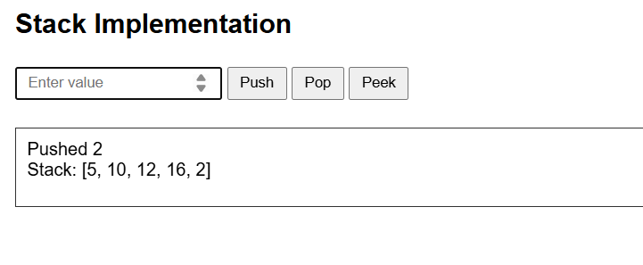
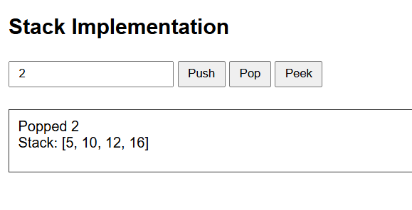
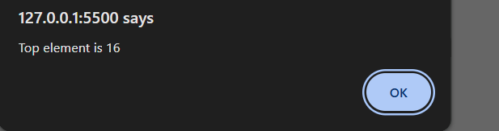

BLOCK DIAGRAM

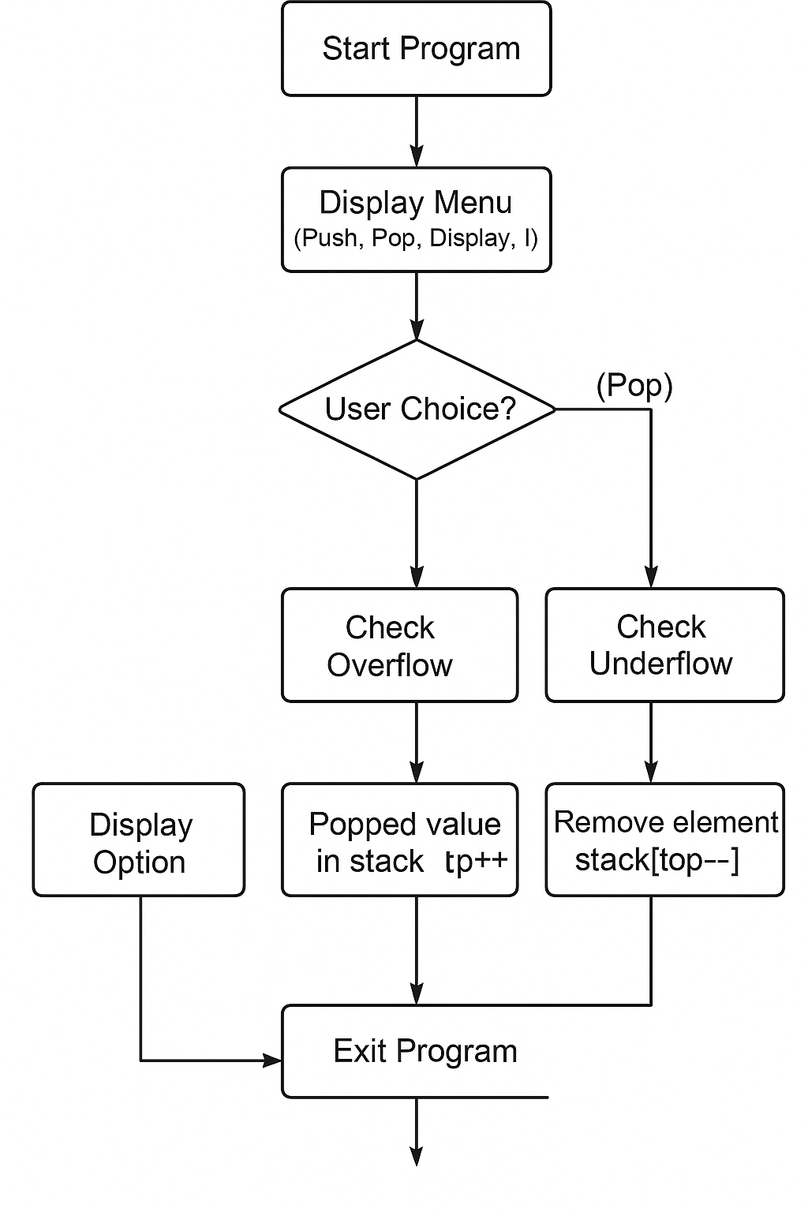

SOFTWARE COMPONENTS

1. Programming Language
The primary software component used in this project is the C programming language. C provides low-level memory access and efficient control structures, which make it ideal for implementing data structures like stacks.

2. Integrated Development Environment (IDE)
An IDE is an essential software component that provides an interface for writing, debugging, and executing the C program. Common IDEs used for this project include:
- Code::Blocks
- Turbo C / Turbo C++
- Dev-C++
- Visual Studio Code
- Online C Compilers (e.g., Replit , Programiz, or Online GDB).

3. Compiler
A C compiler is responsible for converting human-readable source code into machine-executable code.
- GCC (GNU Compiler Collection)
- Turbo C Compiler
- Clang

4. Header Files and Libraries
C language provides a set of header files and standard libraries that facilitate stack operations. The main header files used are:
- #include <stdio.h> – Provides input/output functions like printf() and scanf() for displaying messages and accepting user input.
- #include <stdlib.h> – Provides dynamic memory allocation functions and exit controls.

5. Data Structure Components
The logical software components of the stack include:
- Array Declaration: An array is used to represent the stack where each element is stored sequentially.
- Top Variable: An integer variable top keeps track of the current position of the last inserted element in the stack.

Estimation Cost

Category | Item / Resource | Estimated Cost (INR) | Remarks
Software | C Compiler / IDE (GCC, Turbo C, Code::Blocks, VS Code) | ₹0 | Open-source or free software
Operating System | Windows / Linux | ₹0 | Usually available on personal or lab computers
Hardware | Personal Computer / Laptop | ₹40,000 – ₹60,000 | Already available for academic use
Manpower | Student effort (development & testing) | ₹0 (self) | Done as part of coursework
Electricity / Power | System usage (approx. 10–15 hrs) | ₹50 – ₹100 | Minimal power consumption
Documentation / Printing | Report preparation, printing, and binding | ₹100 – ₹200 | For project submission
Total Estimated Cost | — | ₹150 – ₹300 (excluding system cost) | System and software already available

CONCLUSION
The array implementation of a stack provides a simple and efficient way to understand and work with the LIFO (Last In, First Out) data structure. Through this project, the fundamental operations—push, pop, and display—were successfully implemented using an array and a top pointer, demonstrating how stacks can be managed in a structured manner.
This implementation highlights important concepts such as handling overflow and underflow conditions, memory usage, and menu-driven program design. The project reinforces the importance of stacks in real-world applications such as expression evaluation, function call management, and algorithm design. Overall, the mini-project helps build a strong foundation in data structures and improves both logical thinking and programming skills in the C language.
KEY CONCEPT
The key concept of this project is the implementation of a Stack, a linear data structure that works on the LIFO (Last In, First Out) principle, using a static array in the C programming language. In this method, memory is allocated in a fixed-size array, and a variable called top is used to keep track of the index of the last inserted element.
Stack operations such as Push, Pop, and Display are performed by updating the top pointer while checking for boundary conditions like Stack Overflow (when the stack is full) and Stack Underflow (when the stack is empty). This approach ensures constant-time performance O(1) for all operations, making the array implementation simple, fast, and ideal for understanding the fundamental behavior of the stack data structure.

.

RFERENCES

- E. Balagurusamy, Programming in ANSI C, 8th Edition, McGraw Hill Education, 2019.

- Yashavant Kanetkar, Let Us C, 17th Edition, BPB Publications, 2020.

- Herbert Schildt, C: The Complete Reference, 4th Edition, McGraw Hill Education, 2018.

- Reema Thareja, Data Structures Using C, 2nd Edition, Oxford University Press, 2014.

- GeeksforGeeks, “Stack Data Structure (Introduction and Program),” https://www.geeksforgeeks.org/stack-data-structure.

- TutorialsPoint, “C Programming – Arrays and Stack Implementation,” https://www.tutorialspoint.com/cprogramming.

- Programiz, “C Stack Data Structure – Implementation Using Array,” https://www.programiz.com/dsa/stack.

- NPTEL, Data Structures and Algorithms in C, Ministry of Education, Government of India.

- Javatpoint, “Stack in Data Structure using C,” https://www.javatpoint.com/stack-in-data-structure

